The axiom of continuity of a line
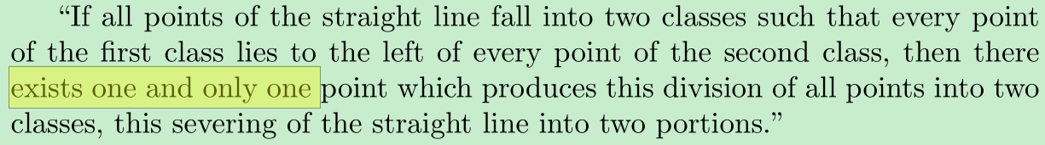
N.B. There is one and only one point that produces the division.“one and only one” requires establishing both existence and uniqueness. Here is a good explanation on the meaning of “one and only one” (see the answer and the comments).
Dedekind's aim was to form the number continuum by making an analogy with the axiom of continuity of a line. He stated (in Chapter V) that if the domain R possesses also continuity, then the following theorem is true:
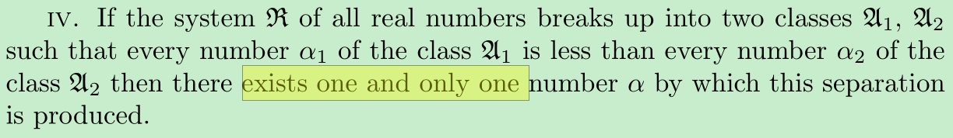
He then showed (in Chapter IV) that there exist infinitely many cuts not produced by rational numbers using the following Dedekind cut
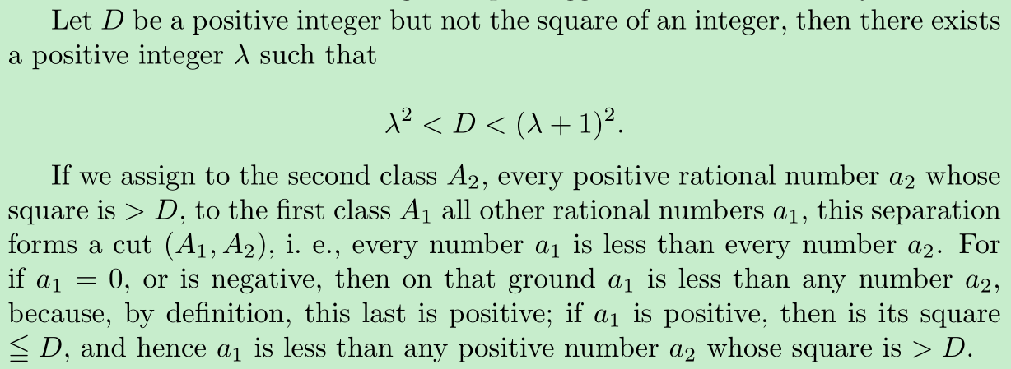
He continued that
But this cut is produced by no rational number. To demonstrate this it must be shown first of all that there exists no rational number whose square = D.
So why he should show there exists no rational number whose square = D first of all ? As far as I know, he just wanted to prepare it as a convenience for the follow-up proof that there is no greatest in the class A₁ by simplifying the cut $A_{1}=\{a∈Q:a^{2}≤2\text{ or }a<0\}$ to $A_{1}=\{a∈Q:a^{2}<2\text{ or }a<0\}$ in this step. After proving that there is neither in the class A₁ a greatest, nor in the class A₂ a least number, so the cut doesn’t satisfy the theorem mentioned above, he then concluded that the cut is not produced by a rational number. In other words, he just proved the existence of non-rational numbers which represents the separation, there is still one more step to go - to prove the uniqueness of the number, since there exists one and only one number by which the separation is produced for a continuous domain. However, Dedekind didn’t give the proof but rather said the following immediately
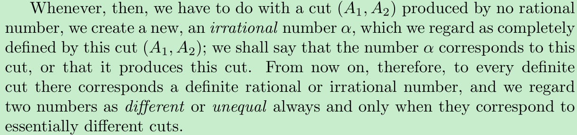
How can Dedekind ensure there is only one irrational number in this case which was completely defined by this cut (A_{1,} A₂)?
This is what I mean by Dedekind did not prove the uniqueness of the number.
BTW, I said “what Dedekind did was firstly assuming all rational numbers formed the number continuum” in the past reply, this is not true after a careful re-reading of his book. Dedekind revealed that there exist infinitely many cuts not produced by rational numbers without assuming all rational numbers formed the number continuum.

I think he should prove
the gap could hold at most one number

You said in last mail that “You seem to be assuming that irrational exist somehow and such a cut should correspond to only one irrational number.” No, I agree with your opinion “I like the modern view that a real number is a Dedekind cut rather that "a Dedekind cut is produced by a real number". The second form in quotes seems to imply that real numbers exist already and they produce the cut. The former statement on the hand means that the cut itself is called a real number.”
During the past mails, perhaps I did not provide a clear description of my opinion, so that led you mainly focused on involving me the uniqueness of the number defined by the cut (In your words, "the cut (A, B) is greater than all the members of A and less than all the members of B. Further, any real number with this property has to be this cut (A, B) only. If the cut is unique so is the thing defined via the cut. ")，while my focus is not on the uniqueness of the number, but on involving you my opinion that Dedekind had not proven why only one number(defined by the cut) is enough to fill the gap.
Dedekind showed that there is a cut produced by no rational number, which revealed a "gap" in the rational numbers, I think he had to prove the "length" of the gap between $A_{1}$ and $A_{2}$ is zero before saying:
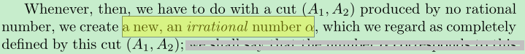
Because if the gap had a positive length, only one new number (defined by the cut) is far from filling the gap, I define the "length" of the gap to be the greatest lower bound of $A≔\left\{a | a=a_{2}-a_{1}, { a}_{1}∈A_{1}{,a}_{2}∈A_{2}\right\}$. Since he skipped the step which I think is essential, then I would question him after he made the definition - why only one number (defined by the cut) is enough to fill the gap so that make the enlarged number system the number continuum?
If you still cannot grasp my meaning, you may query yourself - why Dedekind cut of integers cannot be used as the base to form the number continuum but the rational numbers can?
As for proving the "length" of the gap is zero, density property of rational numbers may be our tool, however, it is not easy for me to give the proof right now, if my opinion is correct, I would share my proof with you later.
As always, correct me if I was wrong, thanks very much!

I’d almost end this mail here, but as I review the mail before sending to you, I did a quick look-up in Dedekind’s book – Fortunately, I think I have found Dedekind’s answer to the above question, although not so explicitly, he wrote:
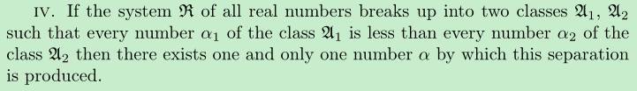
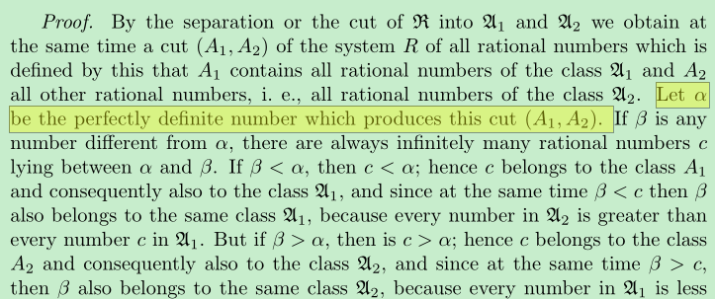
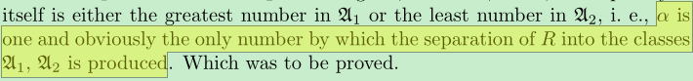
As we see, if we assumed the gap between $A_{1}$ and $A_{2}$ could hold more than one number, we would always
cut ($A_{1}$,$A_{2}$) is

Dear Paramanand,
If you consider what properties a number system should possess so that we could apply Dedekind cuts on it to form the number continuum, then I think you would realize a number system has zero-length gaps is necessary(see a more general discussion here), that’s why we cannot use Dedekind cuts of integers to form the number continuum.
It is the denseness property of rational numbers which ensures the length of a gap between the rationals is zero, so that Dedekind could continue his construction without bother “whether only one number (defined by the cut) is enough to fill the gap”. For if there was a nonzero-length gap between the rationals, then the gap itself is an interval, no matter closed or open, which has positive length and is free from rational, such interval would lead contradiction with the following
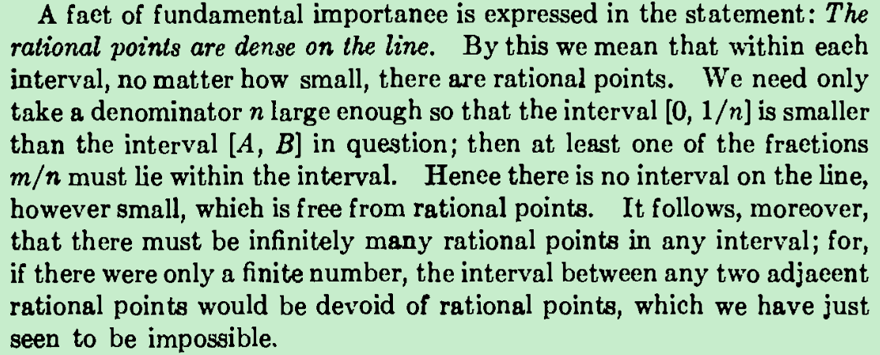
So I think a number system which is incomplete and dense is equivalent to it is has zero-length gaps.
BTW, I think if we prefer to state the denseness property of rational numbers as “there are infinitely many rational numbers in any nonzero-length interval” rather “rational numbers can be found arbitrarily close to any number on the number axis”, it would be much easy and obvious to tackle questions like “whether a gap between the rationals has zero length or not?”.
Sincerely,
Zhao

Dear Paramanand,
I am glad you replied so quickly and help discuss the topic with me till so far, thanks very much!
You said, “the integers are already ordered complete.” I do not understand what you mean by “complete” here. I think completeness means intuitively that there are no “gaps” between two disjoint non-empty sets of numbers, so the integers are incomplete.
The reason why I say that we cannot use Dedekind cuts of integers to form the number continuum is that integers are not dense.
You said, “The need for completeness (or continuum) is to ensure that most of those concepts do not work in vacuum.” I cannot grasp your meaning here. I think the need in completeness (or continuum) is for measurement in theory and modeling the reality as we discussed at MSE before.
As for the teaching schedule for order relations, density and completeness, I agree with your opinion, because these concepts are not that difficult for students in middle schools or high schools to understand. If taught in this period, then, for me, completeness of real numbers would not be a being-told fact, but a true one I can convince myself.
Sincerely,
Zhao

